**Question 1 and 3:**

In this assignment, we are trying to detect non-payer and payer, so that we will offer non-payers some promotion and encourage them to convert.

We can see here, in our sample dataset, the ration between non-payer and payer is 1:14. Most of our users never generate any revenue. And it also indicates that the dataset is imbalanced, and we need to be careful when dealing with data and train our model.

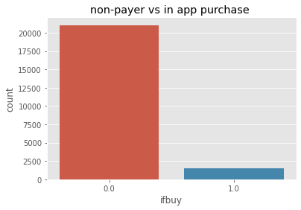

It is very important that we need to exclude all the information after user have the purchases action. This information will cause leakage problems. So the “iaps” dataset is only used for label the users and filter the data before the first purchase date.

I create four extra features: daily average spent gems per user, daily average login times per user, daily average earned gems (not including purchase gems) per user, most frequent login hour per user.

I split the dataset into training set, validation set, and testing set proportionally, which means that each set have the same non-payer and payer ratio.

According to model result, the top four of feature importance is frequent hour, average login times, hw_version, country. The testing data ROC results shows here:

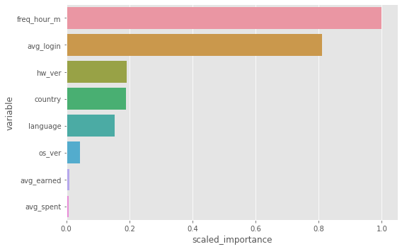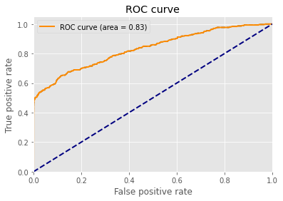

The following four graph shows the distribution of four features:

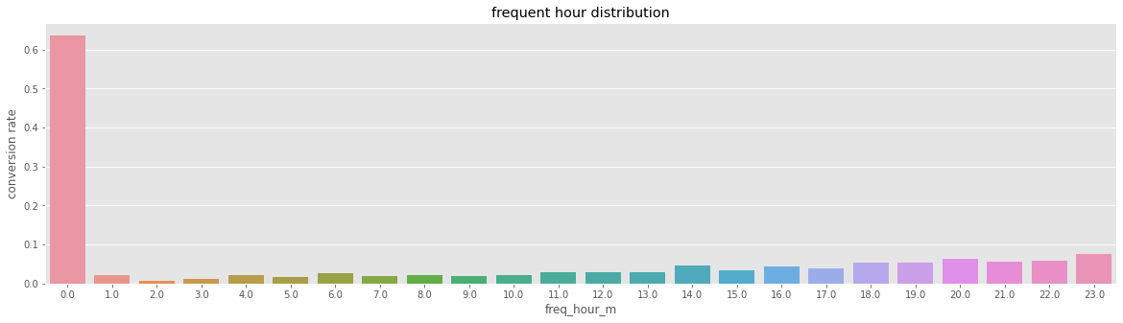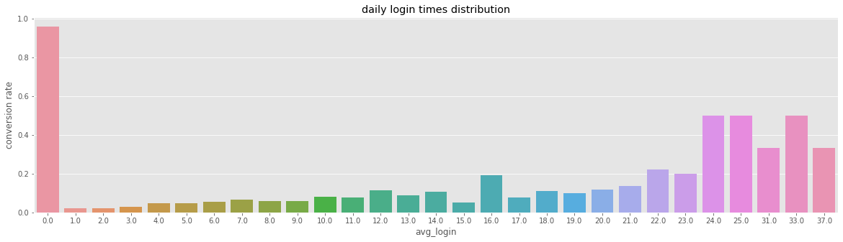

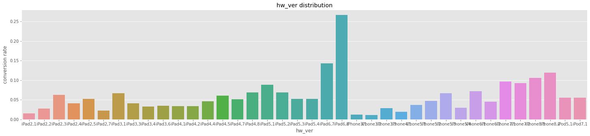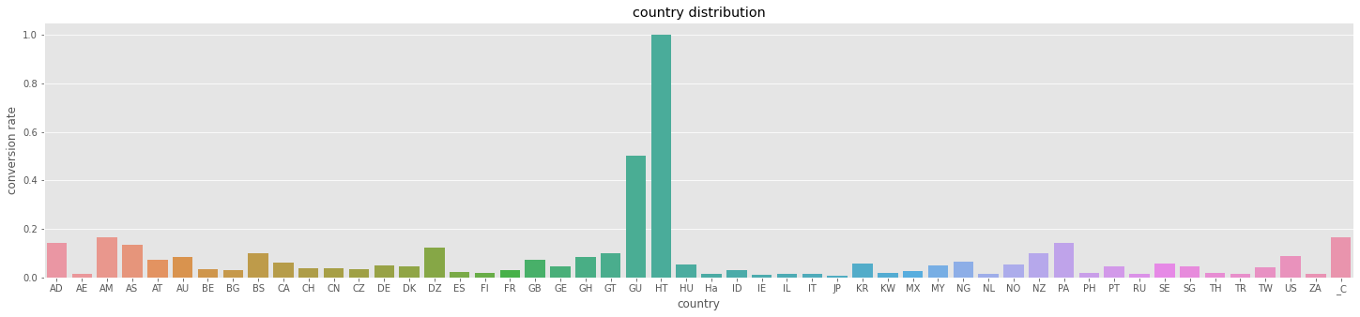

Among all our users, payers are more likely to be:

1. Users who likes playing at night are more likely to convert.
2. Users who are using ipad 6.7 or 6.8 are more likely to convert.
3. Users from AD, AM, AS,BS,DZ,GU,PA,NZ,US are more likely to convert.

**Question 2**

Based on the model built previously, pocket gems can send promotion to the users that are predicted to have higher probability to be non-payers.

To test it, we can conduct A/B test to see if the built model can actually help increase the revenue.

* Choose the average revenue per user to be our key metrics in this test. We can also select some other metrics like DAU or time spent to be monitored. Make sure they will not drop.
* Design test:

1. Randomization Unit: User ID. We randomly assign users to control and experiment groups.
2. Time to run: it is depend on the sample size that we need. There are several parameters that we need to set before test: significant level, practical significant level, power, baseline metric value. After calculating the sample size that we need, the total size divide by the traffic per day will be the time the test needed to run.
3. Sanity check: we need to use the same metrics for sanity check. Make sure that the two groups do no have significant difference.
4. Run the test: In control group, we do nothing here. In the experiment group, we use the model to predict whether the user is a non-payer and we only give the promotion to those users.
5. Preform a one-tail z-test to test whether experiment group's metrics is significantly higher than Control group's metrics.

* Analyzing the result and decide if we use this model to detect non-payers.